

Department of Statistics
Study Topic: Factors Influencing the Tendency to migrate Among Jordanian Youth
Student Names:
Hothaifah Mohammad Shehadah Al-Assi – 2021057039
Ibrahim Hussein Aljarrah – 2022057110
Omar Khaled Sharif Daoud – 2022057127
Huthaifah Mahmoud Ahmad Nazazleh – 2021057204
Omar Khalid Ali AL-Smadi - 2021057241
Qasem Mashhour said al Tamimi – 2021057248
Course Title: Graduation Project / Final Project
Supervisor Name: Dr. Mohammad Al-Qadri
Submission Date: (13/1/2026)

We extend our deepest gratitude and appreciation to our beloved families for their unwavering support, patience, and constant encouragement throughout every step of this project. We also express our sincere thanks to Dr. Mohammad Al-Qadri for his immense support and guidance, which played a major role in the success of our project. His inspiring words motivated us to continue and give our very best. This acknowledgment is offered, from the heart, on behalf of all group members.
Study Title | Page number
Chapter 1: Introduction | 3
1.1: Background | 3
1.2: Objectives | 4
1.3: Research Questions / Hypotheses | 4
1.4: Scope and Limitations | 7
Chapter 2: Literature Review | 8
2.1: summary of relevant research | 8
2.2: Statistical methods used in the literature | 8
2.3: The gap in the literature | 8
2.4: Psychological and Motivational Factors | 9
2.5: Gaps in let | 9
Chapter 3: Data and Methodology | 10
3.1: Data description | 10
3.2: Data Collection Methods | 12
3.3: Statistical Tools and Techniques | 12
3.4: Software Used | 13
Chapter 4: Results and Discussion | 14
4.1: Descriptive Analysis | 14
4.2: Inferential Analysis | 35
4.3: Model Results | 52
4.4: Discussion of Results | 53
Chapter 5: Conclusion and Recommendations | 54
5.1: Conclusion | 54
5.2: Practical Applications | 54
5.3: Limitations of the Study | 55
5.4: Recommendations for Future Work | 55
The References | 56
Questioners/ The peer-reviewed questionnaire | 79-57

Table of Figures:
Bar chart for Descriptive Analysis | 14-20
Box plot for All Themes | 29-35
Plot for Regarrisons | 43-48
Plot for nonparametric | 47-51

Chapter One: Introduction

1.1 Background:
In recent years, the issue of migration has become one of the most prominent social and economic phenomena affecting many countries, particularly developing nations. Youth migration, in particular, has drawn increasing attention due to its significant implications for economic development, social stability, and human capital. High unemployment rates, economic instability, limited job opportunities, and rising living costs have contributed to a growing tendency among young people to consider migration as a viable alternative for improving their living conditions and future prospects.
Beyond economic factors, social and psychological dimensions play a crucial role in shaping migration intentions among youth. Social influences such as family expectations, social networks, and perceived inequality, along with psychological factors including stress, uncertainty about the future, and aspirations for self-fulfillment, have been shown to affect individuals’ decisions to migrate. The interaction between these economic, social, and psychological factors makes migration intention a complex and multidimensional phenomenon that requires comprehensive investigation.
Despite the importance of this issue, empirical research examining migration intention among youth—especially from an integrated perspective that combines economic, social, and psychological factors—remains limited. Understanding how these factors interact and influence migration intention is essential for developing effective policies and interventions aimed at addressing the root causes of youth migration and promoting sustainable development.
Therefore, this study seeks to examine the impact of economic, social, and psychological factors on migration intention among youth. By analyzing these factors and their relative influence, the study aims to provide empirical evidence that can assist policymakers, educators, and social institutions in designing informed strategies to reduce involuntary migration and enhance opportunities for youth within their home country.

1.2 Objective:
1-To identify the level of migration intention among youth.
2-To examine the relationship between economic factors and migration intention among youth.
3-To examine the relationship between social factors and migration intention among youth.
4-To examine the relationship between psychological factors and migration intention among youth.
5-To assess the combined and relative effects of economic, social, and psychological factors on migration intention among youth.
6-To investigate whether migration intention differs according to selected demographic characteristics such as gender, age, educational level, and employment status.

1.3 Research Questions and Hypotheses:

Research questions:
- What are the factors that influence migration status and intention among Jordanian youth and what is the level of their influence?
- What is the level of migration status and intention among Jordanian youth?

- Is there a statistically significant relationship between economic, social, and psychological factors and the intention to migrate among young people?
- Are there statistically significant differences in migration status and intention among Jordanian youth attributable to demographic variables (gender, age, educational level, employment status and marital status )?

Research hypotheses:
1. Economic Factors
Ho₁: There is no statistically significant relationship between economic theme and migration status theme among youth.
H1₁: There is a statistically significant relationship between economic theme and migration status theme among youth.
2. Social Factors
Ho₂: There is no statistically significant relationship between social theme and migration status theme among youth.
H1₂: There is a statistically significant relationship between social theme and migration status theme among youth.
3. Psychological Factors
Ho₃: There is no statistically significant relationship between psychological theme and migration status theme among youth.
H1₃: There is a statistically significant relationship between psychological theme and migration status theme among youth.
- 4. Regression (Impact) Hypotheses
Ho₄: Economic, social, and psychological themes do not have a statistically significant combined effect on migration status theme among youth.
H1₄: Economic, social, and psychological theme have a statistically significant combined effect on migration status theme among youth.
- Individual Effects (Partial Effects)
5. Economic Factors
Ho₅: Economic theme does not have a statistically significant effect on migration status theme among youth.
H1₅: Economic theme has a statistically significant effect on migration status theme among youth.
6. Social Factors
Ho₆: Social theme does not have a statistically significant effect on migration status theme among youth.
H1₆: Social theme has a statistically significant effect on migration status theme among youth.
7. Psychological Factors
Ho₇: Psychological theme does not have a statistically significant effect on migration status theme among youth.
H1₇: Psychological theme has a statistically significant effect on migration status theme among youth.
- Demographic Hypotheses
8. Gender
Ho₈: There are no statistically significant differences in migration status theme between males and females.
H1₈: There are statistically significant differences in migration status theme between males and females.
9. Age
Ho₉: There are no statistically significant differences in migration status theme among different age groups.
H1₉: There are statistically significant differences in migration status theme among different age groups.
10. Educational Level
Ho₁₀: There are no statistically significant differences in migration status theme based on educational level.
H1₁₀: There are statistically significant differences in migration status theme based on educational level.

11. Employment Status
Ho₁₁: There are no statistically significant differences in migration status theme based on employment status.
H1₁₁: There are statistically significant differences in migration status theme based on employment status.
12. Marital Status
Ho₁₂: There are no statistically significant differences in migration status theme based on marital status.
H1₁₂: There are statistically significant differences in migration status theme based on marital status.
1.4 Scope and Limitations:
- Scope of the Study
This study focuses on examining migration intention among youth, with particular emphasis on the economic, social, and psychological factors influencing this intention. The study also investigates differences in migration intention based on selected demographic characteristics, including gender, age, educational level, employment status and marital status.
The data were collected during a specific time period and reflect the perceptions and attitudes of the respondents at the time of data collection. A total of 627 youth respondents participated in the study, selected using Convenience sampling (CS). Data were collected using a structured questionnaire administered electronically.
- Limitations of the Study
Despite the strengths of the study, several limitations should be acknowledged. First, the study relies on self-reported data, which may be subject to response bias or social desirability bias. Second, the data were collected within a limited time frame, which may not fully capture changes in migration intention over time.
Additionally, although Convenience sampling was employed, the sample size represents only a portion of the total youth population, which may limit the generalizability of the findings. Finally, the study focuses on economic, social, and psychological factors, while other potential influences on migration intention—such as political or environmental factors—were not examined.
Chapter Two: Literature Review

2.1 International Perspectives on Migration:
Migration is widely recognized as a multidimensional process shaped by global structural forces. Castles and Miller (2020) argue that international migration is influenced by economic inequalities, political processes, and globalization, positioning migration as a structural phenomenon rather than an individual decision. Their framework provides a foundational understanding of how broader global systems affect individual migration choices.

2.2 Economic Factors:
Economic pressures are consistently identified as primary drivers of migration intentions. Docquier et al. (2019) emphasize that unemployment, wage disparities, and structural labor-market issues motivate individuals to seek opportunities abroad. In Jordan, these challenges are particularly pronounced. Khawaldeh (2021) found that dissatisfaction with income levels, high living costs, and limited job opportunities significantly increase migration intentions among Jordanian youth. Additionally, the International Labour Organization (2021) reports that youth unemployment across Arab states—especially among highly educated individuals—continues to fuel outward migration.

2.3 Social Influences:

Social networks and cultural expectations also play important roles in shaping migration decisions. The Arab Barometer (2022) reports that youth with family or friends living abroad demonstrate significantly higher migration intentions, as social connections reduce both financial and psychological barriers. ARDD (2019) notes that migration is often perceived as a pathway to independence, social mobility, and personal success in Jordan. These social pressures, combined with limited local opportunities, reinforce the desire among youth to seek better conditions elsewhere.

2.4 Psychological and Motivational Factors:

Psychological motivations are increasingly recognized as key contributors to migration decisions. Carling and Schewel (2018) introduce the aspiration–ability framework, which distinguishes between individuals who want to migrate and those who have the means to do so. They argue that emotional dissatisfaction, frustration, and pessimism about future opportunities strongly influence migration aspirations. Supporting this, Arab Barometer (2022) finds that low trust in political institutions and declining life satisfaction is closely associated with youth migration intentions in the Middle East

2.5 Gaps in the Literature:
- Overemphasis on economic factors:
Many Jordanian studies (e.g., Khawaldeh, 2021) focus primarily on economic drivers, with less attention given to social and psychological influences.
- Lack of integrated frameworks:
Regional surveys and reports (Arab Barometer, 2022; ILO, 2021) examine economic or social factors separately but rarely provide a combined, multidimensional analysis.
- Limited Jordan-specific empirical research:
Foundational theoretical works (Castles & Miller, 2020; Carling & Schewel, 2018) are global in scope and not specifically applied to the Jordanian context.
- Insufficient exploration of youth decision-making processes:
ARDD (2019) highlights social and cultural expectations affecting youth migration but calls for more empirical evidence on how these factors interact.
- These gaps highlight the need for future research to adopt a more holistic approach that integrates economic, social, and psychological dimensions to better understand the factors affecting youth migration in Jordan.

Chapter Three: Data and Methodology
3.1 Data Description:
This chapter presents a detailed description of the data used to examine migration intention among youth and to analyze the economic, social, and psychological factors influencing this intention.
The data were collected using a structured questionnaire specifically designed for the purposes of this study. The questionnaire targeted youth respondents and was distributed using a convenience sampling approach, whereby participants were selected based on their availability and willingness to participate. The survey was administered electronically through online platforms, allowing for efficient data collection. The dataset includes demographic variables as well as several key dimensions measuring factors affecting migration intention.
Demographic Variables
The questionnaire collected the following demographic characteristics of the respondents:
- Gender
- Age group
- Educational level
- Employment status
- Marital status
- Region of residence
These variables were used to examine differences in migration intention across different demographic groups.

Study Themes (Independent Variables)
The questionnaire was divided into three main themes, each consisting of several items. Respondents were asked to indicate their level of agreement with each statement using a five-point Likert scale (Strongly Agree, Agree, Neutral, Disagree, Strongly Disagree).

- Economic Factors
This theme measures the impact of economic conditions on migration intention, including low-income levels, unemployment, limited job opportunities, high cost of living, and economic instability.
- Social Factors
This theme examines social influences on migration intention, such as family expectations, social pressure, perceived social inequality, lack of equal opportunities, and the influence of social networks.
- Psychological Factors
This theme focuses on psychological aspects related to migration intention, including anxiety about the future, psychological stress, lack of security, dissatisfaction with current life conditions, and the desire for self-improvement.

Dependent Variable: Migration Intention
Migration intention was measured using a set of items reflecting respondents’ thoughts, desires, and readiness to migrate in search of better opportunities. The average score of these items was calculated and used as the dependent variable in the statistical analysis.

Sample Size
The final sample consisted of 627 youth respondents, selected using a convenience sampling method from a large population estimated at approximately 11 million individuals. Although the sampling approach does not guarantee equal selection probabilities for all members of the population, the sample size is statistically adequate for conducting descriptive and inferential analyses and provides sufficient power to test the study hypotheses.

3.2 Data Collection Methods:
Primary data were collected through a structured, self-administered questionnaire developed specifically to explore migration intention among youth and the factors influencing it.
The questionnaire was distributed electronically to facilitate broad participation and efficient data collection, while maintaining randomness in selection in accordance with the principles of Convenience sampling.
All questionnaire items were measured using a five-point Likert scale, allowing respondents to express varying levels of agreement with each statement.
Ethical Considerations
Ethical standards were strictly observed throughout the data collection process. Participation in the study was entirely voluntary, and respondents were informed that their responses would remain anonymous and would be used solely for academic research purposes. No personal identifiers, such as names or contact information, were collected.

3.3 Statistical Tools and Techniques
After data collection, several statistical tools and techniques were employed to analyze the data and draw valid conclusions regarding migration intention among youth. The analysis consisted of two main stages: descriptive analysis and inferential analysis.

3.3.1 Descriptive Statistics
Descriptive statistics were used to summarize the characteristics of the sample and to describe the general distribution of responses. These included:
- Frequencies and Percentages:
Used to describe demographic characteristics of the respondents.
- Mean:
Used to measure the overall level of migration intention and the level of economic, social, and psychological factors.
- Standard Deviation:
Used to assess the variability and dispersion of respondents’ answers.

3.3.2 Inferential Statistics:
Reliability and Validity Testing
- Reliability Test:
Cronbach’s Alpha was used to assess the internal consistency of the questionnaire themes. Values greater than 0.70 were considered indicative of acceptable reliability.
- Validity Test:
Pearson or Spearman correlation analysis was used to examine construct validity, ensuring that items within each theme were appropriately correlated and aligned with the theoretical framework of the study.
Hypothesis Testing
Several statistical tests were applied to test the study hypotheses:
- Correlation Analysis (Pearson / Spearman):
Used to examine the relationships between economic, social, and psychological factors and migration intention.
- Multiple Linear Regression Analysis:
Used to assess the combined and relative effects of economic, social, and psychological factors on migration intention.
- Mann–Whitney U Test:
Used to examine differences in migration intention between two independent groups (e.g., males and females).
- Kruskal–Wallis H Test:
Used to examine differences in migration intention among more than two independent groups (e.g., age groups or educational levels).

3.4 Software Used
All statistical analyses were conducted using SPSS (Statistical Package for the Social Sciences). The software was used to perform descriptive statistics, correlation analysis, multiple regression analysis, non-parametric tests (Mann–Whitney U and Kruskal–Wallis H), and reliability analysis using Cronbach’s Alpha, ensuring accurate and systematic data analysis.

.
Chapter Four: Results and Discussion
4.1: Descriptive Analysis:
Gender
 | Frequency | Percent | Valid Percent | Cumulative  Percent
Valid Male | 365 | 58.2 | 58.2 | 58.2
Female | 262 | 41.8 | 41.8 | 100.0
Total | 627 | 100.0 | 100.0

The results showed that males constituted 58.2% of the total sample, while females accounted for 41.8%. This distribution indicates a Male dominated representation within the study sample.
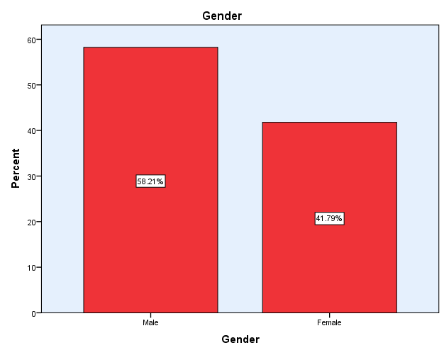

.
Age
Valid | Frequency | Percent | Valid Percent | Cumulative  Percent
18-24 Years | 367 | 58.5 | 58.5 | 58.5
25-29 Years | 115 | 18.3 | 18.3 | 76.9
30 Years or older | 145 | 23.1 | 23.1 | 100.0
Total | 627 | 100.0 | 100.0

The sample was distributed across age groups, with 58.5% aged 18–24 years, followed by 18.3% aged 25–29 years, and 23.1% aged 30 years or older. This distribution reflects a concentration in age groups most relevant to migration-related decisions
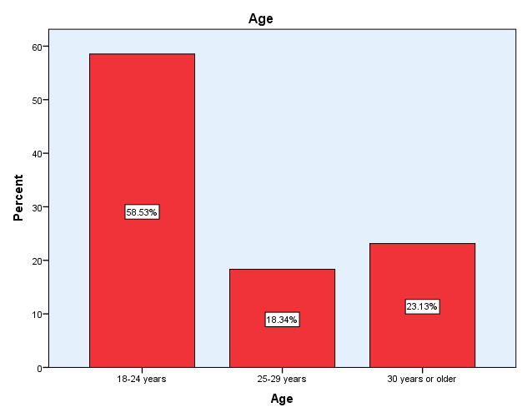

Educational Level
Vaild | Frequency | Percent | Valid Percent | Cumulative  Percent
Secondary or Lower | 77 | 12.3 | 12.3 | 12.3
Diploma/Vocational Training | 121 | 19.3 | 19.3 | 31.6
Bachelor’s Degree | 377 | 60.1 | 60.1 | 91.7
Postgraduate studies | 52 | 8.3 | 8.3 | 100.0
Total | 627 | 100.0 | 100.0

The findings indicated that the majority of respondents held a Bachelor’s qualification 60.1%, while 8.3% had postgraduate degrees and 12.3% had secondary education or lower. This reflects the prevailing educational level among the participating youth
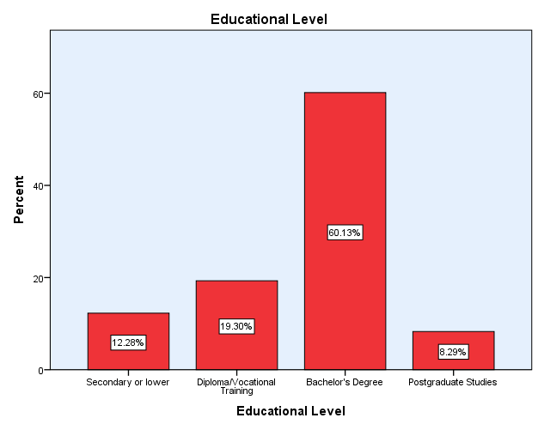

Employment Status
Vaild | Frequency | Percent | Valid Percent | Cumulative  Percent
Unemployed | 118 | 18.8 | 18.8 | 18.8
Part-Time Work | 39 | 6.2 | 6.2 | 25.0
Student | 280 | 44.7 | 44.7 | 69.7
Work in Private Sector | 122 | 19.5 | 19.5 | 89.2
Work in Government Sector | 68 | 10.8 | 10.8 | 100.0
Total | 627 | 100.0 | 100.0

The results showed that 18.8% of respondents were unemployed, 6.2% in Part time Work, 44.7% were students, 19.5% worked in the private sector, and 10.8% in the government sector. This distribution highlights e economic diversity within the sample.

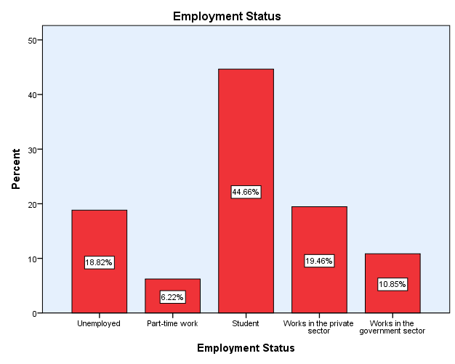
Marital Status
Valid | Frequency | Percent | Valid Percent | Cumulative  Percent
Single | 475 | 75.8 | 75.8 | 75.8
Married | 152 | 24.2 | 24.2 | 100.0
Total | 627 | 100.0 | 100.0

The data revealed that 75.8% of participants were single, while 24.2% were married, indicating that most respondents belong to the unmarried youth group, which is generally more inclined toward migration considerations.
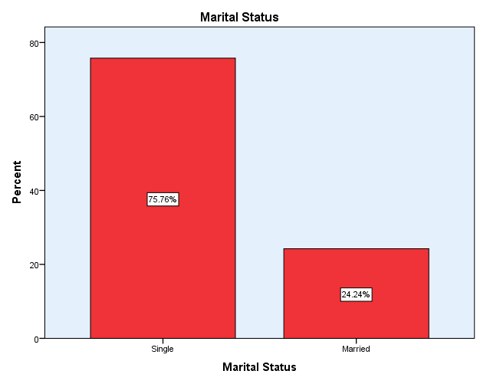

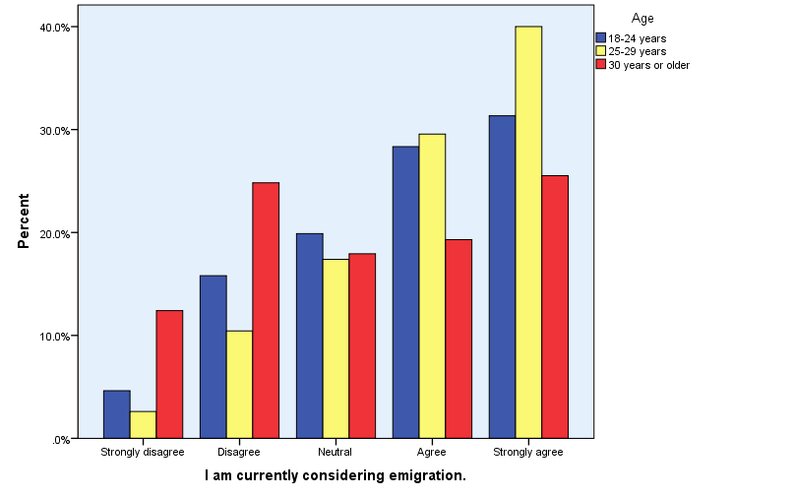

The figure illustrates respondents’ levels of agreement with the statement “I intend to migrate” across different age groups. The results indicate noticeable differences in migration intention by age, with respondents aged 25–29 showing the highest levels of agreement, as the majority selected “Agree” or “Strongly Agree.” The 18–24 age group also demonstrates a relatively high inclination toward migration, though with a more moderate distribution of responses. In contrast, respondents aged 30 years and above exhibit lower migration intention, as reflected by higher proportions in the “Neutral” and “Disagree” categories. Overall, the findings suggest that migration intention increases during early adulthood, peaks among individuals aged 25–29, and declines among older respondents, highlighting age as an important factor influencing migration intention.

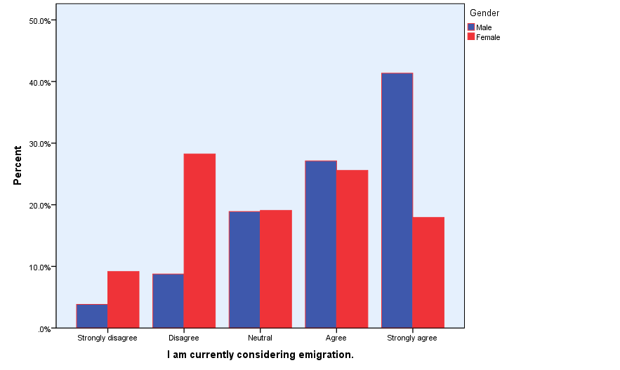

The figure illustrates respondents’ levels of agreement with the statement “I intend to migrate” by gender. The results show noticeable differences between males and females in migration intention. Male respondents exhibit a higher tendency toward migration, as a larger proportion selected “Agree” and “Strongly Agree” compared to females. In contrast, female respondents are more concentrated in the “Disagree” and “Neutral” categories, indicating a relatively lower inclination toward migration. Overall, the chart suggests that migration intention is more pronounced among males than females, highlighting gender as an important demographic factor influencing migration intention.

- Status and intention of migration

Descriptive Statistics
 | N | Mean | Std.  Deviation
I am currently considering emigration. | 627 | 3.61 | 1.25
I believe I have enough information about regular migration. | 627 | 3.41 | 1.06
I believe that irregular migration is fraught with risks. | 627 | 3.88 | 1.01
I believe the Jordanian government provides sufficient  information about the risks of migration. | 627 | 3.33 | 1.14
I want to immigrate to obtain another nationality  or a stronger passport that would make travel easier for me. | 627 | 3.44 | 1.25
I believe the chances of finding a job abroad that matches  my specialization are much higher than in Jordan. | 627 | 4.16 | 1.01
I believe the chances of finding a job abroad that matches  my specialization are much higher than in Jordan.2 | 627 | 3.85 | 1.02

- Economics
Descriptive Statistics
 | N | Mean | Std.  Deviation
I believe that the low level of income, and its inadequacy to cover my basic needs,  is pushing me to think about emigration. | 627 | 4.22 | 0.95
I believe that the lack of job opportunities and high unemployment  rates make migration an attractive option. | 627 | 4.35 | 0.85
I believe that high interest rates and taxes on personal and housing  loans make achieving personal stability almost impossible. | 627 | 4.17 | 0.87
I feel that the absence of government programs to support unemployed youth makes  me feel that my only option is to emigrate. | 627 | 4.12 | 0.90
I believe that the government's economic policies do not create an encouraging  environment for young people to stay and invest in their homeland. | 627 | 4.05 | 0.94
I believe the economic situation in Jordan is getting worse over time. | 627 | 4.08 | 0.98
I believe that other countries provide a more stable and  equitable economic system for ambitious young people. | 627 | 4.11 | 0.87

- Social Influences

Descriptive Statistics
 | N | Mean | Std.  Deviation
I feel that the successful migration experiences I hear about from friends  and the media increase my desire to immigrate. | 627 | 3.88 | 1.02
I feel that my efforts and achievements are not appreciated, which increases my desire to emigrate from the country. | 627 | 3.86 | 1.04
I believe that society does not provide enough space for young people to express themselves. | 627 | 3.98 | 0.97
I think there is a lack of social support from family or the surrounding environment. | 627 | 3.61 | 1.11
I believe that the feeling of marginalization and bullying within society increases my desire to emigrate. | 627 | 3.42 | 1.18
I believe that family pressures increase my desire to emigrate. | 627 | 3.34 | 1.24
I believe that the negative social perception of some professions or specializations increases my desire to emigrate. | 627 | 3.68 | 1.13
I believe that the spread of favoritism and nepotism in the fields of work  and education increases my feeling of inequality and pushes me to emigrate. | 627 | 4.22 | 0.94

- Psychological and Motivational Factors

Descriptive Statistics
 | N | Mean | Std.  Deviation
I feel anxious and insecure about my future and achieving my goals. | 627 | 4.03 | 1.01
I believe that opportunities abroad are fairer and more equal compared to the current situation. | 627 | 4.10 | 0.97
I feel stressed because of the challenges I face. | 627 | 3.98 | 0.98
I find it difficult to adapt to the culture of my community. | 627 | 3.31 | 1.24
I believe that migration represents a personal adventure for me,  and an opportunity to develop my personality, away from comforts. | 627 | 4.04 | 0.96
I believe there is a desire to break free from some of the social constraints in society. | 627 | 3.44 | 1.18

Reliability test:

 | Cronbach’s Alpha | N of Items
Entire questionnaire | 0.913 | 33
Migration status Theme | 0.716 | 7
Economic Theme | 0.880 | 7
Social Theme | 0.858 | 8
Psychological Theme | 0.824 | 6

The results of Cronbach’s Alpha reliability test indicate that the questionnaire used in this study demonstrates a high level of internal consistency. The overall Cronbach’s Alpha coefficient for the entire questionnaire reached 0.913, which reflects an excellent level of internal consistency among the questionnaire items.
At the level of individual themes, the Cronbach’s Alpha value for the migration intention theme was 0.716, which represents an acceptable level of reliability. Meanwhile, the economic, social, and psychological themes achieved high reliability coefficients of 0.880, 0.858, and 0.824, respectively, indicating strong internal consistency among the items within each theme. These results suggest that the questionnaire items measure the intended constructs with a high degree of accuracy, and no items needed to be removed to improve reliability.
Accordingly, the questionnaire data can be considered reliable and suitable for conducting subsequent statistical analyses and drawing valid conclusions.

We have now calculated the averages for each axis separately for use in the analysis.
- Migration status Theme:
Descriptives
 |  |  | Statistic | Std. Error
Migration status Theme | Mean |  | 3.6662 | .02698
 | 95% Confidence Interval for Mean | Lower Bound | 3.6132
 |  | Upper Bound | 3.7192
 | 5% Trimmed Mean |  | 3.6790
 | Median |  | 3.7143
 | Variance |  | .456
 | Std. Deviation |  | .67558
 | Minimum |  | 1.43
 | Maximum |  | 5.00
 | Range |  | 3.57
 | Interquartile Range |  | .86
 | Skewness |  | -.275 | .098
 | Kurtosis |  | -.157 | .195

The descriptive statistics for the migration intention theme indicate that respondents exhibit a moderately high level of migration intention, with a mean score of 3.67 on a five-point Likert scale. The 95% confidence interval for the mean ranges from 3.61 to 3.72, suggesting that the estimated mean is stable and reliable.
The median value (3.71) and the 5% trimmed mean (3.68) are very close to the mean, indicating that the distribution of responses is not substantially affected by extreme values. The standard deviation (0.68) reflects a moderate level of variability in respondents’ migration intentions.
The skewness value (–0.275) and kurtosis value (–0.157) fall within acceptable ranges, indicating that the distribution of the migration intention scores is approximately normal. Overall, these results suggest that respondents tend to lean toward agreement regarding migration intention, supporting the suitability of this variable for subsequent inferential and regression analyses.

Tests of Normality:
Tests of Normality
 | Kolmogorov-Smirnovª |  |  | Shapiro-Wilk
 | Statistic | df | Sig. | Statistic | df | Sig.
Migration status Theme | .066 | 627 | .000 | .987 | 627 | .000
- Lilliefors Significance Correction

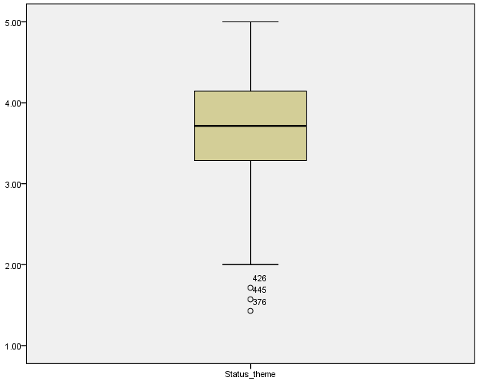

Normality tests indicate that the Migration Status Theme is not normally distributed (p < 0.05), supporting the use of non-parametric statistical methods in the analysis.

- Economic Theme:

Descriptives
 |  |  | Statistic | Std. Error
Economic Theme | Mean |  | 4.1552 | .02769
 | 95% Confidence Interval for Mean | Lower Bound | 4.1008
 |  | Upper Bound | 4.2095
 | 5% Trimmed Mean |  | 4.2001
 | Median |  | 4.1429
 | Variance |  | .481
 | Std. Deviation |  | .69343
 | Minimum |  | 1.86
 | Maximum |  | 5.00
 | Range |  | 3.14
 | Interquartile Range |  | 1.00
 | Skewness |  | -.657 | .098
 | Kurtosis |  | .052 | .195

The descriptive statistics for the Economic Theme indicate a high level of agreement among respondents regarding economic factors related to migration. The mean score reached 4.16 on a five-point Likert scale, suggesting that economic considerations play a prominent role in shaping respondents’ attitudes. The 95% confidence interval for the mean ranges from 4.10 to 4.21, reflecting a stable and precise estimate.
The median value (4.14) and the 5% trimmed mean (4.20) are very close to the mean, indicating that the distribution is not influenced by extreme values. The standard deviation (0.69) reflects a moderate level of dispersion in responses.
Furthermore, the skewness value (–0.657) indicates a slight negative skewness, meaning that responses tend to cluster toward higher agreement levels. The kurtosis value (0.052) falls within the acceptable range, suggesting an approximately normal distribution shape. Overall, these results demonstrate that respondents strongly acknowledge the importance of economic factors, supporting their relevance for further inferential and regression analyses.

- Tests of Normality:
Tests of Normality
 | Kolmogorov-Smirnovª |  |  | Shapiro-Wilk
 | Statistic | df | Sig. | Statistic | df | Sig.
Economic Theme | .112 | 627 | .000 | .930 | 627 | .000
a.Lilliefors Significance Correction

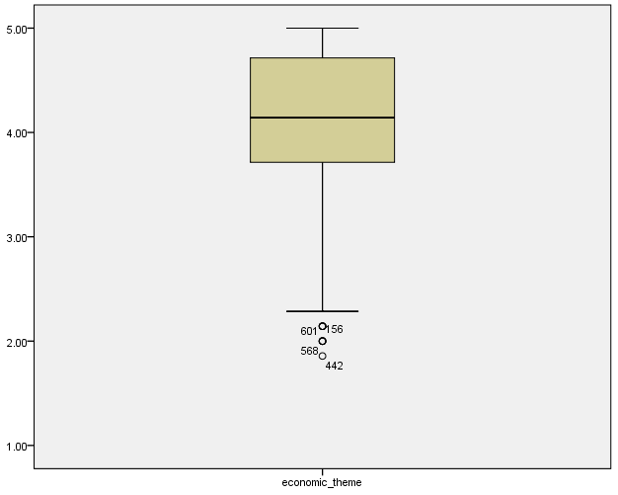
Normality tests indicate that the Economic Theme is not normally distributed (p < 0.05), supporting the use of non-parametric statistical techniques.

- Social Theme:

Descriptives
 |  |  | Statistic | Std. Error
Social Theme | Mean |  | 3.7480 | .03065
 | 95% Confidence Interval for Mean | Lower Bound | 3.6878
 |  | Upper Bound | 3.8082
 | 5% Trimmed Mean |  | 3.7730
 | Median |  | 3.7500
 | Variance |  | .589
 | Std. Deviation |  | .76743
 | Minimum |  | 1.00
 | Maximum |  | 5.00
 | Range |  | 4.00
 | Interquartile Range |  | 1.00
 | Skewness |  | -.275 | .098
 | Kurtosis |  | -.110 | .195

The descriptive statistics for the Social Theme indicate a moderate to moderately high level of agreement among respondents regarding social factors related to migration. The mean score was 3.75 on a five-point Likert scale, suggesting that social considerations are perceived as relatively important, though less influential than economic factors. The 95% confidence interval for the mean ranges from 3.69 to 3.81, indicating a reliable and stable estimate.
The median (3.75) and the 5% trimmed mean (3.77) are very close to the mean, which suggests that the distribution is not affected by extreme values. The standard deviation (0.77) reflects a moderate level of variability in respondents’ perceptions of social factors.
The skewness value (–0.275) indicates a slight negative skewness, while the kurtosis value (–0.110) falls within acceptable limits, suggesting an approximately symmetric distribution. Overall, these findings show that respondents tend to moderately agree with social factors related to migration, supporting the inclusion of this theme in further inferential analyses.

- Tests of Normality:
Tests of Normality
 | Kolmogorov-Smirnovª |  |  | Shapiro-Wilk
 | Statistic | df | Sig. | Statistic | df | Sig.
Social Theme | .067 | 627 | .000 | .974 | 627 | .000
a. Lilliefors Significance Correction

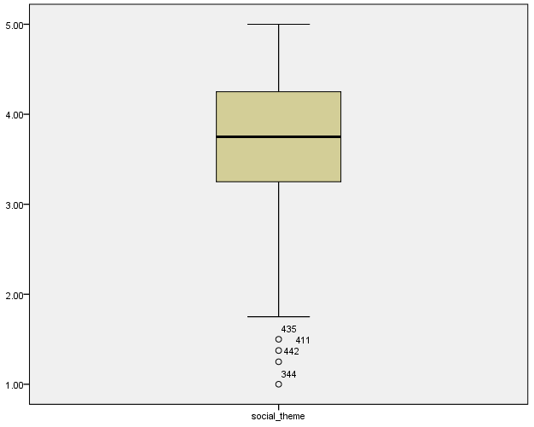

Normality tests indicate that the Social Theme is not normally distributed (p < 0.05), supporting the use of non-parametric statistical techniques.

- Psychological Theme:

Descriptives
 |  |  | Statistic | Std. Error
Psychological Theme | Mean |  | 3.8166 | .03096
 | 95% Confidence Interval for Mean | Lower Bound | 3.7558
 |  | Upper Bound | 3.8774
 | 5% Trimmed Mean |  | 3.8458
 | Median |  | 3.8333
 | Variance |  | .601
 | Std. Deviation |  | .77526
 | Minimum |  | 1.00
 | Maximum |  | 5.00
 | Range |  | 4.00
 | Interquartile Range |  | 1.00
 | Skewness |  | -.353 | .098
 | Kurtosis |  | -.051 | .195

The descriptive statistics for the Psychological Theme indicate a moderately high level of agreement among respondents regarding psychological factors related to migration. The mean score was 3.82 on a five-point Likert scale, suggesting that psychological considerations play an important role in shaping migration intention. The 95% confidence interval for the mean ranges from 3.76 to 3.88, indicating a stable and reliable estimate.
The median (3.83) and the 5% trimmed mean (3.85) are very close to the mean, which suggests that the distribution is not influenced by extreme values. The standard deviation (0.78) reflects a moderate level of variability in respondents’ perceptions of psychological factors.
The skewness value (–0.353) indicates a slight negative skewness, while the kurtosis value (–0.051) falls within acceptable limits, suggesting an approximately symmetric distribution. Overall, these results demonstrate that respondents tend to agree with psychological factors influencing migration, supporting the relevance of this theme for subsequent inferential and regression analyses.

- Tests of Normality:

Tests of Normality
 | Kolmogorov-Smirnovª |  |  | Shapiro-Wilk
 | Statistic | df | Sig. | Statistic | df | Sig.
Psychological Theme | .069 | 627 | .000 | .966 | 627 | .000
a. Lilliefors Significance Correction

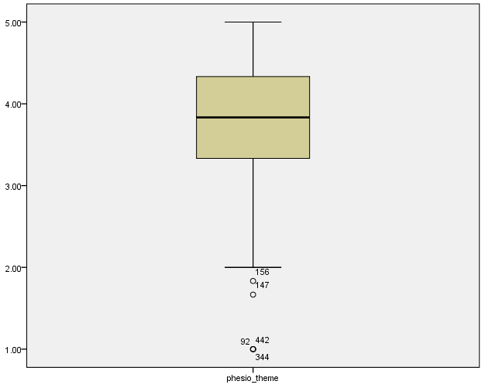

Normality tests indicate that the Psychological Theme is not normally distributed (p < 0.05), supporting the use of non-parametric statistical techniques.
Validity test for status theme:

 | Status theme | I am currently considering emigration. | I believe I have enough information about regular immigration. | I believe that irregular migration is fraught with risks. | I believe the Jordanian government provides sufficient information about the risks of migration. | I want to immigrate to obtain another nationality or a stronger passport that would make travel easier for me. | I believe the chances of finding a job abroad that matches my specialization are much higher than in Jordan. | I believe the chances of finding a job abroad that matches my specialization are much higher than in Jordan.2
Status theme | 1.000 | .730** | .622** | .619** | .280** | .676** | .651** | .634**
I am currently considering emigration. | .730** | 1.000 | .359** | .353** | -.020 | .476** | .522** | .404**
I believe I have enough information about regular immigration. | .622** | .359** | 1.000 | .473** | .182** | .262** | .230** | .262**
I believe that irregular migration is fraught with risks. | .619** | .353** | .473** | 1.000 | .206** | .272** | .287** | .222**
I believe the Jordanian government provides sufficient information about the risks of migration. | .280** | -.020 | .182** | .206** | 1.000 | -.007 | -.033 | -.035
I want to immigrate to obtain another nationality or a stronger passport that would make travel easier for me. | .676** | .476** | .262** | .272** | -.007 | 1.000 | .381** | .407**
I believe the chances of finding a job abroad that matches my specialization are much higher than in Jordan. | .651** | .522** | .230** | .287** | -.033 | .381** | 1.000 | .536**
I believe the chances of finding a job abroad that matches my specialization are much higher than in Jordan.2 | .634** | .404** | .262** | .222** | -.035 | .407** | .536** | 1.000
The validity test for the migration status theme, based on Spearman’s rho correlation coefficients, indicates satisfactory construct validity. All items show positive and statistically significant correlations with the overall migration status theme, with coefficients ranging from moderate to strong (ρ = 0.280 to 0.730, p < 0.01). This suggests that each item is meaningfully related to the underlying construct of migration intention. Although the item related to governmental information shows a relatively weaker correlation, it remains statistically significant, indicating acceptable contribution. Overall, these results confirm that the items adequately measure the migration status theme and support its validity for further analysis.
Validity test for economic theme:
 | economic theme | I believe that the low level of income, and its inadequacy to cover my basic needs, is pushing me to think about emigration. | I believe that the lack of job opportunities and high unemployment rates make immigration an attractive option. | I believe that high interest rates and taxes on personal and housing loans make achieving personal stability almost impossible. | I feel that the absence of government programs to support unemployed youth makes me feel that my only option is to emigrate. | I believe that the government's economic policies do not create an encouraging environment for young people to stay and invest in their homeland. | I believe the economic situation in Jordan is getting worse over time. | I believe that other countries provide a more stable and equitable economic system for ambitious young people.
economic theme | 1.000 | .720** | .763** | .742** | .782** | .807** | .821** | .769**
I am currently considering emigration. | .720** | 1.000 | .691** | .456** | .534** | .450** | .499** | .450**
I believe that the lack of job opportunities and high unemployment rates make immigration an attractive option. | .763** | .691** | 1.000 | .531** | .557** | .499** | .524** | .519**
I believe that high interest rates and taxes on personal and housing loans make achieving personal stability almost impossible. | .742** | .456** | .531** | 1.000 | .561** | .554** | .546** | .505**
I feel that the absence of government programs to support unemployed youth makes me feel that my only option is to emigrate. | .782** | .534** | .557** | .561** | 1.000 | .651** | .542** | .511**
I believe that the government's economic policies do not create an encouraging environment for young people to stay and invest in their homeland. | .807** | .450** | .499** | .554** | .651** | 1.000 | .686** | .575**
I believe the economic situation in Jordan is getting worse over time. | .821** | .499** | .524** | .546** | .542** | .686** | 1.000 | .660**
I believe that other countries provide a more stable and equitable economic system for ambitious young people. | .769** | .450** | .519** | .505** | .511** | .575** | .660** | 1.000

The validity test for the economic theme, based on Spearman’s rho correlation coefficients, demonstrates strong construct validity. All economic items show positive and statistically significant correlations with the overall economic theme, with coefficients ranging from 0.720 to 0.821 (p < 0.01). These strong correlations indicate a high degree of internal coherence and confirm that each item effectively captures key economic dimensions influencing migration intention, such as income inadequacy, unemployment, economic instability, and governmental economic policies. The results support the adequacy of the economic theme for inclusion in subsequent statistical analyses.

 | social theme | I feel that the successful immigration experiences I hear about from friends and the media increase my desire to immigrate. | I feel that my efforts and achievements are not appreciated, which increases my desire to emigrate from the country. | I believe that society does not provide enough space for young people to express themselves. | I think there is a lack of social support from family or the surrounding environment. | I believe that the feeling of marginalization and bullying within society increases my desire to emigrate. | I believe that family pressures increase my desire to emigrate. | I believe that the negative social perception of some professions or specializations increases my desire to emigrate. | I believe that the spread of favoritism and nepotism in the fields of work and education increases my feeling of inequality and pushes me to emigrate.
social theme | 1.000 | .648** | .680** | .707** | .723** | .755** | .741** | .770** | .605**
I feel that the successful immigration experiences I hear about from friends and the media increase my desire to immigrate. | .648** | 1.000 | .570** | .422** | .324** | .342** | .383** | .437** | .434**
I feel that my efforts and achievements are not appreciated, which increases my desire to emigrate from the country. | .680** | .570** | 1.000 | .554** | .369** | .371** | .355** | .427** | .479**
I believe that society does not provide enough space for young people to express themselves. | .707** | .422** | .554** | 1.000 | .518** | .434** | .385** | .474** | .503**
I think there is a lack of social support from family or the surrounding environment. | .723** | .324** | .369** | .518** | 1.000 | .569** | .493** | .512** | .314**
I believe that the feeling of marginalization and bullying within society increases my desire to emigrate. | .755** | .342** | .371** | .434** | .569** | 1.000 | .592** | .568** | .321**
I believe that family pressures increase my desire to emigrate. | .741** | .383** | .355** | .385** | .493** | .592** | 1.000 | .540** | .326**
I believe that the negative social perception of some professions or specializations increases my desire to emigrate. | .770** | .437** | .427** | .474** | .512** | .568** | .540** | 1.000 | .424**
I believe that the spread of favoritism and nepotism in the fields of work and education increases my feeling of inequality and pushes me to emigrate. | .605** | .434** | .479** | .503** | .314** | .321** | .326** | .424** | 1.000
Validity test for social theme:

 | psychological theme | I feel anxious and insecure about my future and achieving my goals. | I believe that opportunities abroad are fairer and more equal compared to the current situation. | I feel stressed because of the challenges I face. | I find it difficult to adapt to the culture of my community. | I believe that immigration represents a personal adventure for me, and an opportunity to develop my personality, away from comforts. | I believe there is a desire to break free from some of the social constraints in society.
psychological theme | 1.000 | .746** | .715** | .771** | .751** | .709** | .721**
I feel anxious and insecure about my future and achieving my goals. | .746** | 1.000 | .599** | .643** | .421** | .511** | .357**
I believe that opportunities abroad are fairer and more equal compared to the current situation. | .715** | .599** | 1.000 | .572** | .360** | .558** | .347**
I feel stressed because of the challenges I face. | .771** | .643** | .572** | 1.000 | .471** | .512** | .388**
I find it difficult to adapt to the culture of my community. | .751** | .421** | .360** | .471** | 1.000 | .380** | .571**
I believe that immigration represents a personal adventure for me, and an opportunity to develop my personality, away from comforts. | .709** | .511** | .558** | .512** | .380** | 1.000 | .421**
I believe there is a desire to break free from some of the social constraints in society. | .721** | .357** | .347** | .388** | .571** | .421** | 1.000
Validity test for psychological theme:

The validity test for the psychological theme, based on Spearman’s rho correlation coefficients, indicates strong construct validity. All psychological items exhibit positive and statistically significant correlations with the overall psychological theme, with coefficients ranging from 0.709 to 0.771 (p < 0.01). These strong associations demonstrate a high level of internal consistency and confirm that the items effectively capture key psychological dimensions related to migration intention, such as anxiety about the future, stress, perceived inequality, personal aspirations, and the desire for self-development. Accordingly, the psychological theme is deemed valid and appropriate for inclusion in further statistical analyses
4.2 Inferential Analysis:
After conducting descriptive statistics for the demographic variables and questionnaire items, validity analysis was performed to ensure that the questionnaire items adequately measured their intended constructs. Subsequently, reliability analysis using Cronbach’s alpha was conducted to assess the internal consistency of each study themes.
Economic theme and Migration status theme:
Ho₁: There is no statistically significant relationship between economic theme and Migration status theme among youth.
H1₁: There is a statistically significant relationship between economic theme and Migration status theme among youth.

Correlations
Spearman's rho |  | Migration status theme | Economic theme
Migration status theme | Correlation Coefficient | 1.00 | 0.580**
 | Sig. (2-tailed) | . | 0.000
 | N | 627 | 627
Economic theme | Correlation Coefficient | 0.580** | 1.000
 | Sig. (2-tailed) | 0.000 | .
 | N | 627 | 627
**. Correlation is significant at the 0.01 level (2-tailed).

Spearman’s rank correlation analysis shows a moderate positive and statistically significant relationship between economic theme and Migration status theme (ρ = 0.580, p < 0.01). This finding indicates that respondents who agreed more strongly with statements related to low-income levels, limited job opportunities, high unemployment, rising living costs, and the belief that better economic opportunities exist abroad also reported a higher intention to migrate. This suggests that perceptions of economic conditions, as measured in the questionnaire, are closely associated with youths’ migration intentions.

Social Theme and Migration status theme:
Ho₂: There is no statistically significant relationship between social theme and migration status theme among youth.
H1₂: There is a statistically significant relationship between social theme and migration status theme among youth.

Correlations
Spearman's rho |  | Migration status theme | Social Theme
Migration status theme | Correlation Coefficient | 1.00 | 0.517**
 | Sig. (2-tailed) | . | 0.000
 | N | 627 | 627
Social Theme | Correlation Coefficient | 0.517** | 1.000
 | Sig. (2-tailed) | 0.000 | .
 | N | 627 | 627
**. Correlation is significant at the 0.01 level (2-tailed).

The results reveal a moderate positive and statistically significant relationship between social theme and migration status theme (ρ = 0.517, p < 0.01). This indicates that respondents who expressed stronger agreement with statements related to social pressures, perceived inequality, favoritism, lack of fairness in opportunities, and the influence of social environment tended to report a higher intention to migrate. The finding highlights the role of social conditions, as captured by the questionnaire items, in shaping migration intention.

Psychological theme and Migration status theme:
Ho₃: There is no statistically significant relationship between psychological theme and migration status theme among youth.
H1₃: There is a statistically significant relationship between psychological theme and migration status theme among youth.

Correlations
Spearman's rho |  | Migration status theme | Psychological Theme
Migration status theme | Correlation Coefficient | 1.00 | 0.532**
 | Sig. (2-tailed) | . | 0.000
 | N | 627 | 627
Psychological Theme | Correlation Coefficient | 0.532** | 1.000
 | Sig. (2-tailed) | 0.000 | .
 | N | 627 | 627
**. Correlation is significant at the 0.01 level (2-tailed).

Spearman’s correlation analysis indicates a moderate positive and statistically significant relationship between psychological theme and migration status theme (ρ = 0.532, p < 0.01). This result suggests that respondents who reported higher levels of agreement with statements reflecting psychological stress, anxiety about the future, lack of security, and the desire for personal development and self-realization were more likely to express an intention to migrate. This confirms the relevance of psychological dimensions measured in the questionnaire in explaining migration intention among youth.

Regarrisons:
Main Regression Hypothesis:
Ho₄: Economic, social, and psychological themes do not have a statistically significant combined effect on migration status theme among youth.
H1₄: Economic, social, and psychological themes have a statistically significant combined effect on migration status theme among youth.

Model Summary^{b}
Model | R | R Square | Adjusted R Square | Std. Error of the Estimate | Change Statistics
 |  |  |  |  | R Square Change | F Change | df1 | df2 | Sig. F Change
1 | .609ª | .371 | .368 | .53711 | .371 | 122.457 | 3 | 623 | .000
a. Predictors: (Constant), Psychological Theme, Economic theme, social theme
b. Dependent Variable: Migration status theme
The model summary indicates a multiple correlation coefficient (R) of 0.609, suggesting a moderate to strong overall relationship between economic, social, and psychological themes and migration status theme. The coefficient of determination (R² = 0.371) shows that approximately 37.1% of the variance in migration intention is explained by the model. The adjusted R² value (0.368) confirms the stability and adequacy of the model. Furthermore, the significant F-change value (p < 0.05) indicates that the regression model as a whole is statistically significant.

ANOVA
Model |  | Sum of Squares | df | Mean Square | F | Sig.
1 | Regression | 105.983 | 3 | 35.328 | 122.457 | .000^{b}
 | Residual | 179.731 | 623 | .288
 | Total | 285.714 | 626
a. Dependent Variable: Migration status theme
b. Predictors: (Constant), Psychological Theme, Economic theme, social theme

The ANOVA results indicate that the regression model is statistically significant (F = 122.457, p < 0.05). This finding demonstrates that the economic, social, and psychological themes jointly explain a significant proportion of the variance in migration status theme, confirming the overall validity of the regression model.
Coefficients
a. Dependent Variable: Migration status theme

Model |  | Unstandardized Coefficients |  | Standardized Coefficients | T | Sig. | 95.0% Confidence Interval for B |  | Collinearity Statistics
 |  | B | Std. Error | Beta |  |  | Lower Bound | Upper Bound | Tolerance | VIF
1 | (Constant) | 1.162 | .134 |  | 8.686 | .000 | .900 | 1.425
 | Economic theme | .346 | .044 | .355 | 7.775 | .000 | .259 | .433 | .484 | 2.065
 | social theme | .066 | .049 | .074 | 1.342 | .180 | -.030 | .161 | .328 | 3.045
 | Psychological Theme | .215 | .045 | .247 | 4.770 | .000 | .127 | .304 | .377 | 2.652
Fitted model:
Migration Intention = 1.162 + 0.346(Economic Theme) + 0.066(Social Theme) + 0.215(Psychological Theme).

Collinearity Diagnostics
Model | Dimension | Eigenvalue | Condition Index | Variance Proportions
 |  |  |  | (Constant) | Economic theme | Social theme | Psychological Theme
1 | 1 | 3.957 | 1.000 | .00 | .00 | .00 | .00
 | 2 | .024 | 12.852 | .67 | .00 | .10 | .11
 | 3 | .011 | 19.278 | .21 | .65 | .03 | .50
 | 4 | .008 | 21.985 | .12 | .35 | .86 | .38
- Dependent Variable: Migration status theme

The regression coefficients indicate that economic theme have a positive and statistically significant effect on migration status theme and represent the strongest predictor in the model. Psychological theme also shows a positive and significant effect, whereas social theme do not exhibit a statistically significant independent effect when included alongside the other variables. Collinearity diagnostics, including VIF and tolerance values, indicate no multicollinearity issues among the independent variables, confirming the robustness of the regression model.

Economic Factors
Ho₅: Economic theme does not have a statistically significant effect on migration status theme among youth.
H1₅: Economic theme has a statistically significant effect on migration status theme among youth.
Collinearity Diagnostics

Model |  | Unstandardized Coefficients |  | Standardized Coefficients | t | Sig. | 95.0% Confidence Interval for B |  | Collinearity Statistics
 |  | B | Std. Error | Beta |  |  | Lower Bound | Upper Bound | Tolerance | VIF
 | Economic theme | .346 | .044 | .355 | 7.775 | .000 | .259 | .433 | .484 | 2.065
The regression analysis revealed that economic theme has a positive and statistically significant effect on migration status theme among youth (p < 0.05). Therefore, the null hypothesis (H0₅) is rejected, and the alternative hypothesis (H1₅) is accepted. This result indicates that changes in economic conditions, as measured by the economic theme in the questionnaire, significantly contribute to explaining variations in migration status theme among youth.
Social Factors
- Ho₆: Social theme does not have a statistically significant effect on migration status theme among youth.
- H1₆: Social theme has a statistically significant effect on migration status theme among youth.
Collinearity Diagnostics

Model |  | Unstandardized Coefficients |  | Standardized Coefficients | t | Sig. | 95.0% Confidence Interval for B |  | Collinearity Statistics
 |  | B | Std. Error | Beta |  |  | Lower Bound | Upper Bound | Tolerance | VIF
 | social theme | .066 | .049 | .074 | 1.342 | .180 | -.030 | .161 | .328 | 3.045
The results of the regression analysis show that social theme do not have a statistically significant independent effect on migration status theme among youth when controlling for economic and psychological themes (p > 0.05). Accordingly, the null hypothesis (H0₆) is accepted, and the alternative hypothesis (H1₆) is rejected. This suggests that although social factors may be associated with migration status theme, their effect is not statistically significant within the regression model.
Psychological Factors
Ho₇: Psychological theme does not have a statistically significant effect on migration status theme among youth.
H1₇: Psychological factors have a statistically significant effect on migration intention among youth.

Model |  | Unstandardized Coefficients |  | Standardized Coefficients | t | Sig. | 95.0% Confidence Interval for B |  | Collinearity Statistics
 |  | B | Std. Error | Beta |  |  | Lower Bound | Upper Bound | Tolerance | VIF
 | Psychological Theme | .215 | .045 | .247 | 4.770 | .000 | .127 | .304 | .377 | 2.652
Collinearity Diagnostics

The regression results indicate that psychological theme have a positive and statistically significant effect on migration status theme among youth. The psychological theme shows a significant standardized coefficient (β = 0.247), with an unstandardized coefficient (B = 0.215), a t-value of 4.770, and a significance level of p < 0.001. Moreover, the 95% confidence interval for B (0.127–0.304) does not include zero, confirming the robustness of this effect. Accordingly, the null hypothesis is rejected, and H1₇ is supported, indicating that psychological theme play a meaningful role in shaping migration status theme among youth.

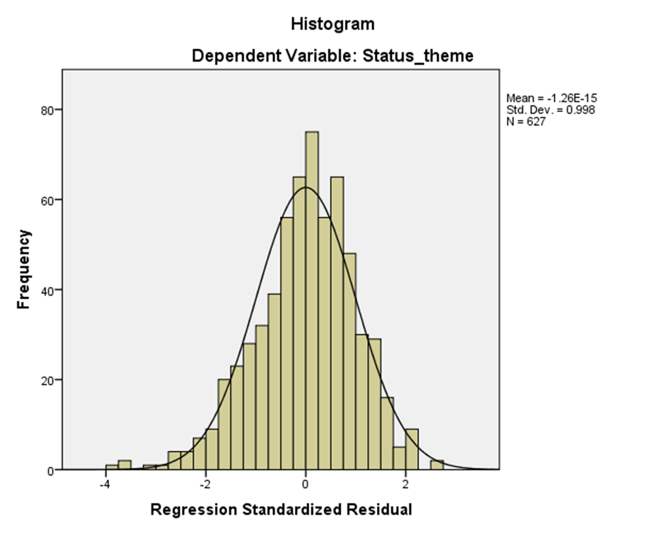
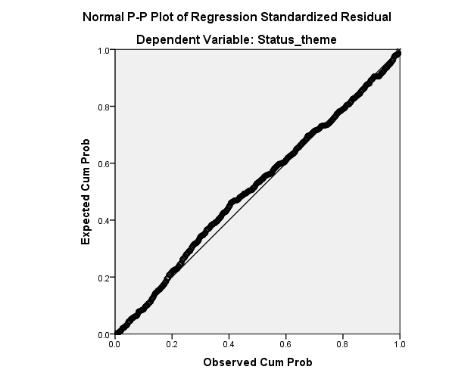

The Normal P–P plot of the standardized residuals shows that the data points closely follow the diagonal reference line, with only minor deviations at the extremes. This indicates that the residuals are approximately normally distributed, confirming that the normality assumption of the regression model is satisfied.
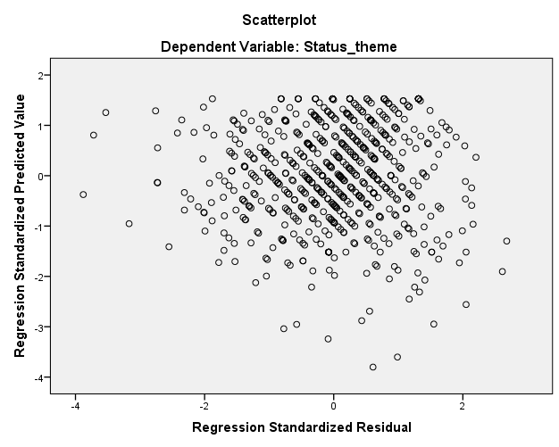
The scatterplot of standardized residuals against standardized predicted values shows a random dispersion of points around zero with no systematic pattern. This indicates that the assumptions of linearity and homoscedasticity are satisfied, supporting the adequacy of the regression model.

The model after removing the social theme (backward method):
Model Summary
Model | R | R Square | Adjusted R Square | Std. Error of the Estimate | Change Statistics
 |  |  |  |  | R Square Change | F Change | df1 | df2 | Sig. F Change
1 | .609ª | .371 | .368 | .53711 | .371 | 122.457 | 3 | 623 | .000
2 | .608^{b} | .369 | .367 | .53746 | -.002 | 1.802 | 1 | 623 | .180
a. Predictors: (Constant), Psychological Theme, economic theme, social theme
b. Predictors: (Constant), Psychological Theme, economic theme
c. Dependent Variable: migration Status theme
After applying the backward elimination method, the social theme was removed from the regression model due to its lack of statistical significance. The results show that excluding the social theme led to a negligible change in the model’s explanatory power, with R² decreasing only from 0.371 to 0.369 (ΔR² = −0.002), and this change was not statistically significant (F change = 1.802, p = 0.180). The adjusted R² values remained almost identical (0.368 and 0.367), indicating strong model stability. Accordingly, the reduced model including only economic and psychological themes is more parsimonious and effectively explains approximately 36.9% of the variance in migration intention, confirming that economic and psychological factors are the primary drivers of migration intention among youth, while social factors do not contribute significantly when these variables are considered.
Anova
Model |  | Sum of Squares | df | Mean Square | F | Sig.
1 | Regression | 105.983 | 3 | 35.328 | 122.457 | .000^{b}
 | Residual | 179.731 | 623 | .288
 | Total | 285.714 | 626
2 | Regression | 105.464 | 2 | 52.732 | 182.549 | .000^{c}
 | Residual | 180.251 | 624 | .289
 | Total | 285.714 | 626
- Dependent Variable: Status theme/b. Predictors: (Constant), Psychological Theme, economic theme, social theme
c. Predictors: (Constant), Psychological Theme, economic theme
The ANOVA results indicate that both regression models are statistically significant in explaining variation in the migration status theme. In Model 1, which includes the economic, psychological, and social themes, the regression model is highly significant (F = 122.457, p < 0.001), demonstrating that the predictors jointly explain a significant portion of the variance in migration intention. Similarly, Model 2, which excludes the social theme and includes only the economic and psychological themes, also shows strong statistical significance (F = 182.549, p < 0.001). The continued significance of the reduced model confirms that removing the social theme does not compromise the overall explanatory power of the regression. These results further support the conclusion that economic and psychological factors are sufficient and effective predictors of migration intention, while the social theme does not add a significant explanatory contribution when included alongside theme.
Coefficients
Model |  | Unstandardized Coefficients |  | Standardized Coefficients | t | Sig. | Collinearity Statistics
 |  | B | Std. Error | Beta |  |  | Tolerance | VIF
1 | (Constant) | 1.162 | .134 |  | 8.686 | .000
 | economic theme | .346 | .044 | .355 | 7.775 | .000 | .484 | 2.065
 | social theme | .066 | .049 | .074 | 1.342 | .180 | .328 | 3.045
 | Psychological Theme | .215 | .045 | .247 | 4.770 | .000 | .377 | 2.652
2 | (Constant) | 1.167 | .134 |  | 8.719 | .000
 | economic theme | .371 | .040 | .380 | 9.154 | .000 | .585 | 1.709
 | Psychological Theme | .251 | .036 | .288 | 6.935 | .000 | .585 | 1.709
a. Dependent Variable: migration Status theme
Fitted model:
Migration Intention = 1.167 + 0.371(Economic Theme) + 0.251(Psychological Theme).
The regression coefficients indicate that in Model 1, both the economic theme and the psychological theme have positive and statistically significant effects on migration intention, while the social theme does not. Specifically, the economic theme shows a strong and significant effect (B = 0.346, β = 0.355, p < 0.001), followed by the psychological theme (B = 0.215, β = 0.247, p < 0.001), whereas the social theme is not statistically significant (B = 0.066, β = 0.074, p = 0.180). After removing the social theme in Model 2, both remaining predictors remain highly significant, with the economic theme emerging as the strongest predictor (B = 0.371, β = 0.380, p < 0.001), followed by the psychological theme (B = 0.251, β = 0.288, p < 0.001). The improvement in standardized coefficients in the reduced model suggests a clearer and more stable explanatory structure. Additionally, all VIF values are below 2, indicating no multicollinearity concerns. Overall, these results confirm that economic and psychological factors are the primary determinants of migration intention, while social factors do not contribute significantly when other variables are controlled for.
Model |  | Beta In | t | Sig. | Partial Correlation | Collinearity Statistics
 |  |  |  |  |  | Tolerance | VIF | Minimum Tolerance
2 | migration Status theme | .074^{b} | 1.342 | .180 | .054 | .328 | 3.045 | .328
Excluded Variables

a. Dependent Variable: migration Status theme
b. Predictors in the Model: (Constant), Psychological Theme, economic theme
The excluded variables table indicates that the social theme was removed due to its lack of statistical significance (β = 0.074, t = 1.342, p = 0.180) and minimal unique explanatory power (partial correlation = 0.054). Since its inclusion does not improve the model, retaining only the economic and psychological themes results in a more parsimonious and statistically efficient regression model.
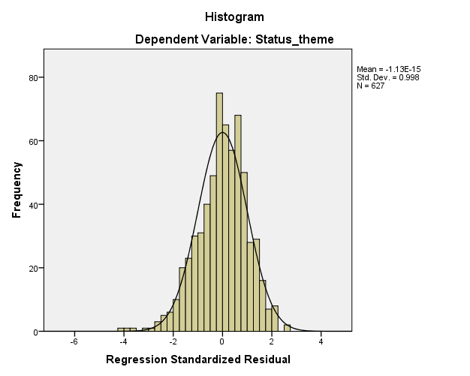

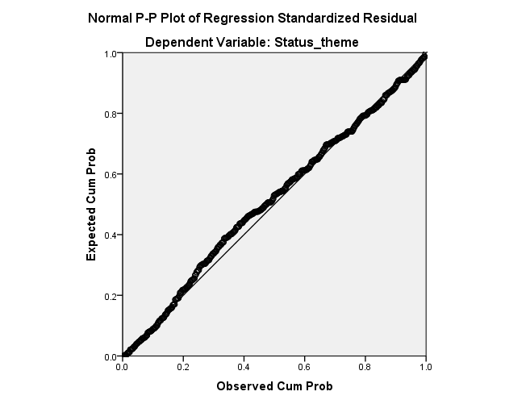
The Normal P–P Plot of the standardized regression residuals shows that the observed cumulative probabilities closely follow the diagonal reference line. This indicates that the residuals are approximately normally distributed, with no substantial deviations from normality. Accordingly, the normality assumption of the regression residuals is reasonably satisfied, supporting the validity and reliability of the estimated regression model and confirming that the inferential results derived from the model can be interpreted with confidence.

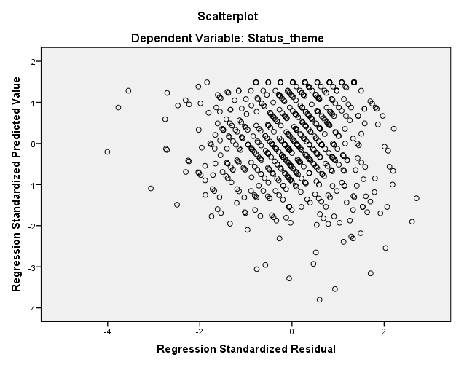

The scatterplot of standardized residuals versus standardized predicted values shows a random and approximately symmetric distribution of points around the zero li+ne, with no clear pattern or funnel shape. This indicates that the assumption of homoscedasticity (constant variance of residuals) is reasonably satisfied. Additionally, the absence of a systematic structure or curvature suggests that the relationship between the independent variables and the dependent variable is adequately modeled as linear. Although a few extreme residuals are observed, they do not appear to substantially distort the overall pattern. Overall, the scatterplot supports the validity of the regression model assumptions and confirms the reliability of the estimated results

Gender and Migration status theme:
Ho₈: There are no statistically significant differences in migration status theme between males and females.
H1₈: There are statistically significant differences in migration status theme between males and females.
Mann-Whitney Test:
Ranks
 | Gender | N | Mean Rank | Sum of Ranks
Migration status theme | Male | 365 | 345.37 | 126060.00
 | Female | 262 | 270.30 | 70818.00
 | Total | 627

Test Statistics
 | Migration status theme
Mann-Whitney U | 36365.000
Wilcoxon W | 70818.000
Z | -5.129
Asymp. Sig. (2-tailed) | .000
a. Grouping Variable: Gender

The results of the Mann–Whitney U test indicate a statistically significant difference in migration status theme between males and females (Asymp. Sig. = 0.000 < 0.05). The mean rank for males (345.37) is higher than that for females (270.30), suggesting that males exhibit a higher level of migration stats theme compared to females. Accordingly, the null hypothesis is rejected, and the alternative hypothesis is accepted.

Age and Migration status theme:
Ho₉: There are no statistically significant differences in migration status theme among different age groups.
H1₉: There are statistically significant differences in migration status theme among different age groups

Kruskal-Wallis Test:

Ranks
 | Age | N | Mean Rank
Migration status theme | 18-24 years | 367 | 320.31
 | 25-29 years | 115 | 358.31
 | 30 years or older | 145 | 262.90
 | Total | 627

Test Statistics
 | Migration status theme
Chi-Square | 18.944
df | 2
Asymp. Sig. | .000
a. Kruskal Wallis Test
b. Grouping Variable: Age

The different comes from:
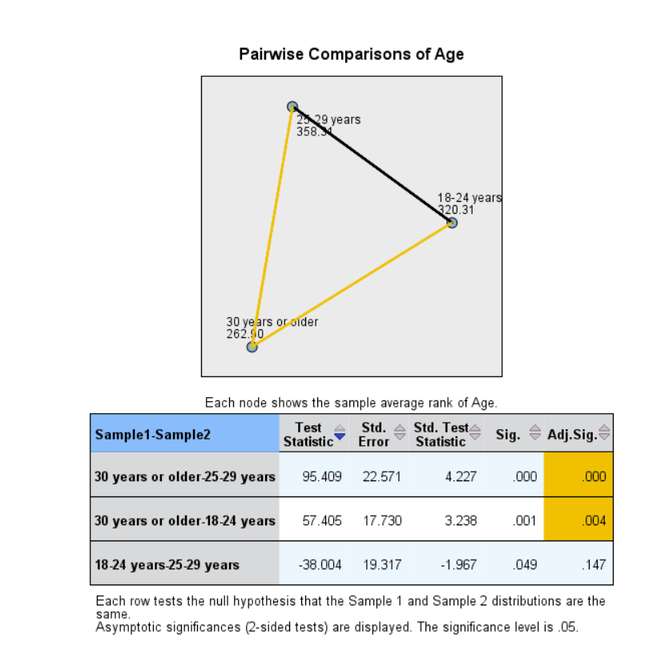
The Kruskal–Walli’s test revealed a statistically significant difference in migration status theme across age groups (p < 0.05). Post-hoc pairwise comparisons using the Mann–Whitney U test with Bonferroni adjustment indicated significant differences between the age group (30 years and above) and both the (18–24) and (25–29) age groups. However, no statistically significant difference was found between the (18–24) and (25–29) age groups. The mean ranks show that migration status theme was highest among respondents aged 25–29 and lowest among those aged 30 and above.

Educational Level and Migration status theme:
Ho₁₀: There are no statistically significant differences in migration status theme based on educational level.
H1₁₀: There are statistically significant differences in migration status theme based on educational level.
Kruskal-Wallis Test:
Ranks
 | Educational Level | N | Mean Rank
Migration status theme | Secondary or lower | 77 | 337.92
 | Diploma/Vocational Training | 121 | 275.25
 | Bachelor's Degree | 377 | 326.92
 | Postgraduate Studies | 52 | 275.12
 | Total | 627

Test Statistics
 | Migration status theme
Chi-Square | 11.239
df | 3
Asymp. Sig. | .011
a. Kruskal Wallis Test
b. Grouping Variable: Educational Level

The Kruskal–Walli’s test was conducted to examine whether migration intention (migration status theme) differs across educational levels. The results indicate a statistically significant difference in migration intention among the different educational groups (χ² = 11.239, df = 3, p = 0.011).
Accordingly, the null hypothesis (H0₁₀) is rejected, and the alternative hypothesis (H1₁₀) is accepted, indicating that migration intention varies significantly based on educational level.
The mean rank results show that respondents with secondary education or lower have the highest mean rank (337.92), followed by those holding a bachelor’s degree (326.92), suggesting relatively higher migration intention among these groups. In contrast, respondents with diploma/vocational training (275.25) and postgraduate studies (275.12) exhibit lower mean ranks, indicating comparatively lower migration intention.
These findings suggest that educational level plays a meaningful role in shaping migration intention, although the strength and direction of this intention differ across educational categories.
The different comes from:
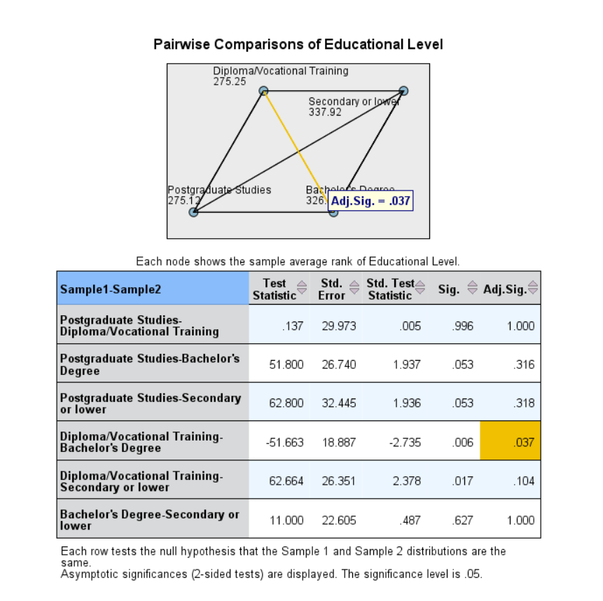
The post hoc pairwise comparisons reveal that there is a statistically significant difference in migration status theme between respondents holding a Diploma/Vocational Training and those holding a Bachelor’s Degree (Adjusted p = 0.037 < 0.05). This indicates that migration intention differs significantly between these two educational groups.
The mean rank values show that respondents with a Bachelor’s Degree have a higher mean rank (326.92) compared to those with a Diploma/Vocational Training (275.25), suggesting a stronger migration status theme among bachelor’s degree holders.
In contrast, no statistically significant differences were found between Postgraduate Studies and any of the other educational levels, nor between Secondary or Lower education and the remaining groups after applying the Bonferroni adjustment (Adjusted p > 0.05). This indicates that migration status theme is relatively similar across these educational categories.
Overall, these findings suggest that educational level plays a role in migration intention, particularly when comparing bachelor’s degree holders with diploma or vocational training respondents.
Employment and Migration status theme:
Ho ₁₁: There are no statistically significant differences in migration status theme based on employment status.
H1₁₁: There are statistically significant differences in migration status theme based on employment status.
Rank
 | Employment Status | N | Mean Rank
Migration  Status theme | Unemployed | 118 | 330.89
 | Part-time work | 39 | 314.87
 | Student | 280 | 310.82
 | Works in the private sector | 122 | 348.23
 | Works in the government sector | 68 | 235.90
 | Total | 627

Test Statistics
 | Status theme
Chi-Square | 18.187
df | 4
Asymp. Sig. | .001
a. Kruskal Wallis Test
b. Grouping Variable: Employment Status

The results of the Kruskal–Walli’s test indicate that there are statistically significant differences in migration status theme across different employment status groups (χ² = 18.187, df = 4, p = 0.001). This result leads to the rejection of the null hypothesis, suggesting that migration intention varies significantly according to employment status.
The mean rank values show that respondents who work in the private sector have the highest mean rank (348.23), indicating the strongest migration intention. This is followed by the unemployed group (330.89), part-time workers (314.87), and students (310.82). In contrast, respondents who work in the government sector have the lowest mean rank (235.90), reflecting a comparatively lower migration intention.
These findings suggest that employment stability, particularly employment in the government sector, may reduce migration intention, while less stable or private-sector employment is associated with higher migration intention.
The Different comes from:
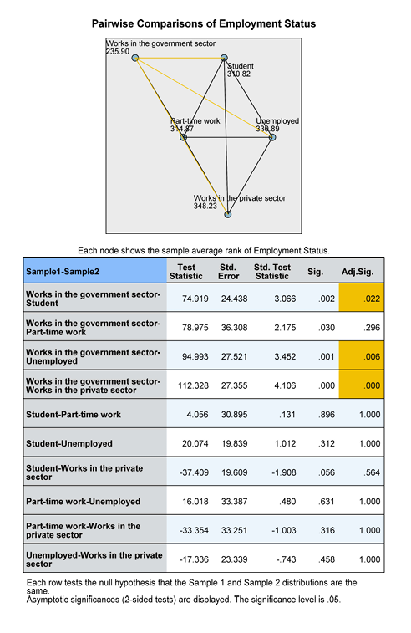
These findings suggest that job stability and employment security associated with government sector employment may reduce individuals’ inclination to emigrate. Conversely, economic pressure, job insecurity, and limited career advancement opportunities in the private sector, as well as unemployment, appear to increase migration status theme among youth.
Marital Status:
Ho₁₂: There are no statistically significant differences in migration status theme based on marital status.
H1₁₂: There are statistically significant differences in migration status theme based on marital status.
Mann-Whitney Test:

Ranks
 | Marital Status | N | Mean Rank | Sum of Ranks
Migration Status theme | Single | 475 | 330.81 | 157134.50
 | Married | 152 | 261.47 | 39743.50
 | Total | 627

Test Statistics
 | Migration Status theme
Mann-Whitney U | 28115.500
Wilcoxon W | 39743.500
Z | -4.116
Asymp. Sig. (2-tailed) | .000

a. Grouping Variable: Marital Status

The Mann–Whitney U test results indicate a statistically significant difference in migration status theme based on marital status (Sig. = 0.000 < 0.05). Accordingly, the null hypothesis is rejected, indicating that migration intention differs significantly across marital status categories.

4.3 Model Results
To examine the effect of the main study themes on migration intention among youth, a multiple linear regression model was estimated with migration intention (Migration Status Theme) as the dependent variable, and the economic, social, and psychological themes as independent variables.
Model Fit:
The regression results indicate that the model is statistically significant. As shown in the Model Summary table, the correlation coefficient (R) is 0.609, indicating a moderate overall relationship between the independent variables and migration intention. The coefficient of determination (R² = 0.371) suggests that approximately 37.1% of the variance in migration intention is explained by the three themes included in the model. The adjusted R² value (0.368) confirms the stability and adequacy of the model.
The ANOVA results further support the model’s significance (F = 122.457, p < 0.001), indicating that the set of predictors collectively provides a statistically meaningful explanation of migration intention.
Regression Coefficients:
The coefficients table reveals differing effects of the independent variables:
Economic Theme shows a positive and statistically significant effect on migration intention (B = 0.346, β = 0.355, p < 0.001). This indicates that higher economic pressures and perceived economic opportunities abroad are associated with increased migration intention.
Psychological Theme also has a positive and statistically significant effect (B = 0.215, β = 0.247, p < 0.001), suggesting that psychological factors such as stress, anxiety, and desire for self-development play an important role in shaping migration intention.
Social Theme, however, does not exhibit a statistically significant effect on migration intention (B = 0.066, β = 0.074, p = 0.180), indicating that social factors do not significantly predict migration intention when economic and psychological factors are controlled for.
Model Diagnostics:
Multicollinearity diagnostics show acceptable values for all predictors, with VIF values below 3.1, indicating no serious multicollinearity issues. The Normal P–P plot of standardized residuals shows that residuals closely follow the diagonal line, and the residual scatterplot indicates no clear pattern, supporting the assumptions of normality and homoscedasticity of residuals.
Overall, the regression model is statistically sound and suitable for interpreting the effects of the study themes on migration intention.
4.4 Discussion of Results:

The findings of this study provide clear empirical evidence regarding the factors influencing migration intention among youth.
The economic theme emerged as the strongest predictor of migration intention. This result reflects the central role of economic conditions, such as unemployment, income instability, and better job prospects abroad, in motivating youth to consider migration. This aligns with migration theories that emphasize economic push and pull factors as primary drivers of migration decisions.
The psychological theme also demonstrated a significant positive effect, highlighting the importance of individual-level factors such as stress, anxiety about the future, perceived lack of fulfillment, and the desire for personal growth. These findings suggest that migration intention is not solely an economic decision but is also deeply rooted in psychological well-being and self-perception.

In contrast, the social theme did not show a statistically significant effect in the regression model. Although social factors were correlated with migration intention in earlier analyses, their influence diminished when economic and psychological factors were considered simultaneously. This suggests that social pressures may operate indirectly or overlap with other dimensions rather than independently driving migration intention.
The model explains a substantial proportion of variance in migration intention (37.1%), indicating that while economic and psychological factors are crucial, other unobserved factors—such as political conditions, institutional trust, or personal networks—may also contribute to migration decisions.
Overall, the results underscore the multidimensional nature of migration intention, with economic and psychological drivers playing a more decisive role than social factors among the studied population.

Chapter Five: Conclusion and Recommendation
5.1 Conclusion:
This study aimed to examine the factors influencing migration intention among youth by focusing on three main dimensions: economic, social, and psychological factors. Using a structured questionnaire and appropriate statistical analyses, the study provided empirical evidence on the role of these factors in shaping youths’ migration intentions.
The findings revealed that migration intention among the respondents was moderately high. The economic factors emerged as the strongest and most influential predictor of migration intention, indicating that issues such as employment opportunities, income levels, and economic stability play a crucial role in motivating youth to consider migration. Psychological factors also showed a statistically significant positive effect, suggesting that feelings of dissatisfaction, personal aspirations, and perceived future prospects significantly contribute to migration intentions. In contrast, social factors did not demonstrate a statistically significant independent effect when analyzed alongside economic and psychological factors, despite showing moderate levels of agreement in descriptive analysis.
Overall, the regression model was statistically significant and explained a meaningful proportion of the variance in migration intention, confirming the robustness of the study’s analytical framework. These results highlight the multifaceted nature of migration intention and underscore the importance of addressing economic and psychological dimensions when analyzing youth migration trends.

5.2 Practical Applications:
The findings of this study offer several practical implications for policymakers, educational institutions, and labor market stakeholders. First, addressing economic challenges such as unemployment, low wages, and limited career advancement opportunities may reduce migration intentions among youth. Policies aimed at job creation, entrepreneurship support, and improving working conditions could play a vital role in retaining young talent.
Second, the significant role of psychological factors suggests the need for programs that enhance youth well-being, career guidance, and future planning. Providing counseling services, mentorship programs, and opportunities for personal development may help youth feel more optimistic about their prospects within their home country.
Finally, although social factors were not statistically significant predictors in the regression model, their moderate influence indicates that social environments should not be overlooked. Strengthening community engagement and social support networks may indirectly contribute to reducing migration intentions.

5.3 Limitations of the Study:

Despite its contributions, this study has several limitations. First, the data were collected using a self-reported questionnaire, which may be subject to response bias. Second, the study relied on a cross-sectional design, limiting the ability to draw causal conclusions about the relationships between variables. Third, the sample was confined to a specific population, which may limit the generalizability of the findings to other contexts or age groups.

Additionally, although the model explained a substantial portion of the variance in migration intention, other factors not included in this study—such as political or environmental factors—may also play a role.

5.4 Recommendations for Future Work:

Future research is recommended to expand on the findings of this study in several ways. Longitudinal studies are recommended to examine how migration intentions evolve over time and how changes in economic or psychological conditions influence decision-making. Additionally, policymakers and future researchers are recommended to consider incorporating additional variables, such as political stability and environmental concerns, to provide a more comprehensive understanding of migration intentions.

Moreover, qualitative approaches, including interviews or focus groups, are recommended to complement quantitative findings by offering deeper insights into the personal experiences and motivations underlying migration decisions. Policymakers may also benefit from extending future studies to include different regions or age groups, which would enhance the generalizability of the results and support the development of more targeted migration-related policies.

The References

Arab Barometer. (2022). Youth and migration in the Middle East and North Africa. https://www.arabbarometer.org
Arab Renaissance for Democracy and Development. (2019). Jordanian youth and their decision-making processes regarding their futures. https://ardd-jo.org/wp-content/uploads/2023/02/Youth-and-Emigration.pdf
Castles, S., & Miller, M. J. (2020). The age of migration: International population movements in the modern world (6th ed.). Guilford Press.
International Labour Organization. (2021). Youth employment and migration in Arab States. https://www.ilo.org
Khawaldeh, M. (2021). Economic challenges and migration intentions among Jordanian youth.
Docquier, F., Peri, G., & Ruyssen, I. (2019). The economics of migration: Theory and evidence. In Handbook of labor, human resources and population economics (pp. 1–41). Springer. https://doi.org/10.1007/978-3-319-57365-6_116-1

Factors Influencing the Tendency to Emigrate Among Jordanian Youth:

Peace, mercy, and blessings of God be upon you.
Dear esteemed participant, Greetings.
This survey is part of a research study aimed at examining the economic, social, and psychological factors influencing the tendency of Jordanian youth to emigrate. This survey is part of the requirements for completing a graduation thesis for a Bachelor's degree at Yarmouk University.
Your participation will greatly contribute to understanding the factors contributing to the increasing phenomenon of emigration. Since answering this survey is optional and confidential, and no names or specific personal information will be mentioned in the results, and the survey will only take a few minutes, we kindly ask you to answer it objectively and honestly. Thank you very much for your valuable contribution.
First: Personal Information:
Gender: ☐ Male ☐ Female
Age: ☐ 18-24 years ☐ 25-29 years ☐ 30 years or older
Educational Level: ☐ Secondary or lower ☐ Diploma/Vocational Training ☐ Bachelor's Degree ☐ Postgraduate Studies
Employment Status: ☐ Unemployed ☐ Part-time work ☐ Student ☐ Works in the private sector
☐ Works in the government sector
Marital Status: ☐ Single ☐ Married
Area of ​​Residence: ☐ Northern Jordan ☐ Central Jordan ☐ Southern Jordan
Second: Status and intention of migration:
Paragraph No. | Paragraph | Strongly agree | Agree | Neutral | Disagree | Strongly disagree
1 | I am currently considering emigration.
2 | I believe I have enough information about regular migration.
3 | I believe that irregular migration is fraught with risks.
4 | I believe the Jordanian government provides sufficient information about the risks of migration.
5 | I want to immigrate to obtain another nationality or a stronger passport that would make travel easier for me.
6 | I believe the chances of finding a job abroad that matches my specialization are much higher than in Jordan.
7 | Other countries offer a fairer and more incentive-based tax system.

First axis: Economic factors:
Paragraph No. | Paragraph | Strongly agree | Agree | Neutral | Disagree | Strongly disagree
1 | I believe that the low level of income, and its inadequacy to cover my basic needs, is pushing me to think about emigration.
2 | I believe that the lack of job opportunities and high unemployment rates make migration an attractive option.
3 | I believe that high interest rates and taxes on personal and housing loans make achieving personal stability almost impossible.
4 | I feel that the absence of government programs to support unemployed youth makes me feel that my only option is to emigrate.
5 | I believe that the government's economic policies do not create an encouraging environment for young people to stay and invest in their homeland.
6 | I believe the economic situation in Jordan is getting worse over time.
7 | I believe that other countries provide a more stable and equitable economic system for ambitious young people.

Second axis: Social factors:
Paragraph No. | Paragraph | Strongly agree | Agree | Neutral | Disagree | Strongly disagree
1 | I feel that the successful migration experiences I hear about from friends and the media increase my desire to immigrate.
2 | I feel that my efforts and achievements are not appreciated, which increases my desire to emigrate from the country.
3 | I believe that society does not provide enough space for young people to express themselves.
4 | I think there is a lack of social support from family or the surrounding environment.
5 | I believe that the feeling of marginalization and bullying within society increases my desire to emigrate.
6 | I believe that family pressures increase my desire to emigrate.
7 | I believe that the negative social perception of some professions or specializations increases my desire to emigrate.
8 | I believe that the spread of favoritism and nepotism in the fields of work and education increases my feeling of inequality and pushes me to emigrate.

Third axis: Psychological factors:
Paragraph No. | Paragraph | Strongly agree | Agree | Neutral | Disagree | Strongly disagree
1 | I feel anxious and insecure about my future and achieving my goals.
2 | I believe that opportunities abroad are fairer and more equal compared to the current situation.
3 | I feel stressed because of the challenges I face.
4 | I find it difficult to adapt to the culture of my community.
5 | I believe that migration represents a personal adventure for me, and an opportunity to develop my personality, away from comforts.
6 | I believe there is a desire to break free from some of the social constraints in society.

العوامل المؤثرة في التوجه نحو الهجرة بين الشباب الأردني

السلام عليكم ورحمة الله و بركاته.
عزيزي /عزيزتي المشارك المحترم/ة. تحية طيبة وبعد.
فهذا الاستبيان جزء من دراسة بحثية تهدف إلى دراسة العوامل الاقتصادية والاجتماعية والنفسية التي تؤثر في توجه الشباب الأردني نحو الهجرة. علما أن هذا الاستبيان يُعد جزءًا من متطلبات إعداد بحث تخرج لنيل درجة البكالوريوس في جامعة اليرموك.
إن مشاركتكم ستساهم بشكل كبير في فهم العوامل المؤثرة في تفاقم ظاهرة الهجرة، و لإن الإجابة عن هذا الاستبيان اختيارية وسرية، لن يتم ذكر أسماء أو معلومات شخصية محددة في النتائج، وهذا الاستبيان يستغرق بضع دقائق.
فنرجو التكرم بالإجابة عنه بكل موضوعية وصدق، مع شكرنا الجزيل لمساهمتكم القيمة.
أولاً :المعلومات الشخصية :
الجنس: ☐ ذكر ☐ أنثى
العمر: ☐ 18-24سنة ☐25-29 سنة ☐30 سنة أو أكثر
المستوى التعليمي: ☐ثانوي او أقل ☐دبلوم/تدريب مهني ☐بكالوريوس ☐دراسات عليا
الحاله الوظيفية: ☐بلا عمل ☐طالب ☐ يعمل بدوام جزئي ☐يعمل في قطاع خاص ☐يعمل في قطاع حكومي
الحالة الاجتماعية: ☐أعزب/عزباء ☐متزوج/متزوجة
منطقة السكن: ☐إقليم الشمال ☐إقليم الوسط ☐ إقليم الجنوب
____________________________________________________________
ثانيا:حالة و نية الهجرة :
غير موافق بشدة | غير موافق | محايد | موافق | موافق بشدة | الفقرة | رقم الفقرة
 |  |  |  |  | أفكر حاليًا في الهجرة. | 1
 |  |  |  |  | أعتقد أن لدي معلومات كافية عن الهجرة النظامية. | 2
 |  |  |  |  | أعتقد أن الهجرة غير النظامية محفوفة بالمخاطر. | 3
 |  |  |  |  | أرى أن الحكومة الأردنية تقدم معلومات كافية عن مخاطر الهجرة. | 4
 |  |  |  |  | أرغب في الهجرة لأجل الحصول على جنسية أخرى أو  .جواز سفر أقوى يسهل لي التنقل | 5
 |  |  |  |  | أرى أن فرصة الحصول على وظيفة في الخارج .تتناسب مع تخصصي أعلى بكثير من الأردن | 6
 |  |  |  |  | الدول الأخرى توفر نظاماً ضريبياً أكثر عدلاً وحافزاً للعمل. | 7

______________________________________________
المحور الأول: العوامل الاقتصادية:
غير موافق بشدة | غير موافق | محايد | موافق | موافق بشدة | الفقرة | رقم الفقرة
 |  |  |  |  | أعتقد أن تدني مستوى الدخل، وعدم كفايته لتغطيه حاجاتي الأساسية، يدفعني الى التفكير في الهجرة. | 1
 |  |  |  |  | أرى أن عدم توافر فرص العمل، وارتفاع معدلات البطالة، يجعل الهجرة خيارًا جذابًا. | 2
 |  |  |  |  | أعتقد أن ارتفاع أسعار الفائدة والضرائب على القروض الشخصية والسكنية، يجعل تحقيق الاستقرار الشخصي أمراً شبه مستحيل. | 3
 |  |  |  |  | أرى أن غياب البرامج الحكومية لدعم الشباب العاطلين عن العمل، يشعرني بأن فرصتي الوحيدة هي الهجرة. | 4
 |  |  |  |  | أرى أن السياسات الاقتصادية للحكومة لا تخلق بيئة مشجعة للشباب على البقاء والاستثمار في وطنهم. | 5
 |  |  |  |  | أعتقد أن الوضع الاقتصادي في الأردن يزداد سوءًا مع مرور الوقت. | 6
 |  |  |  |  | أرى أن الدول الأخرى توفر نظامًا اقتصاديًا أكثر استقرارًا وعدالةً للشباب الطموح. | 7

المحور الثاني: العوامل الاجتماعية:
غير موافق بشدة | غير موافق | محايد | موافق | موافق بشدة | الفقرة | رقم الفقرة
 |  |  |  |  | أشعر بأن تجارب الهجرة الناجحة التي أسمعها من الأصدقاء والإعلام تزيد من رغبتي في الهجرة. | 1
 |  |  |  |  | أشعر بأن جهودي وإنجازاتي غير مقدرة، مما يزيد من رغبتي في الهجرة خارج البلد. | 2
 |  |  |  |  | أرى أن المجتمع لا يوفر المساحة الكافية للشباب للتعبير عن أنفسهم. | 3
 |  |  |  |  | أعتقد عدم وجود الدعم الاجتماعي من الأسرة أو البيئة المحيطة. | 4
 |  |  |  |  | أعتقد أن الشعور بالتهميش والتنمر داخل المجتمع يزيد من رغبتي في الهجرة. | 5
 |  |  |  |  | أرى أن الضغوط العائلية تزيد من رغبتي في الهجرة. | 6
 |  |  |  |  | أعتقد أن النظرة الاجتماعية السلبية لبعض المهن أو التخصصات تزيد من رغبتي في الهجرة. | 7
 |  |  |  |  | أرى أن انتشار الواسطة والمحسوبية في مجالات العمل والتعليم، يزيد من شعوري بعدم المساواة، ويدفعني الى الهجرة. | 8

المحور الثالث: العوامل النفسية:

غيرموافق بشدة | غير موافق | محايد | موافق | موافق بشدة | الفقرة | رقم الفقرة
 |  |  |  |  | أشعر بالقلق وعدم الأمان بشأن مستقبلي وتحقيق أهدافي. | 1
 |  |  |  |  | أعتقد أن الفرص في الخارج أكثر عدلًا وتكافؤًا مقارنة بالوضع الحالي. | 2
 |  |  |  |  | أشعر بالضغط النفسي؛ بسبب التحديات التي أواجهها. | 3
 |  |  |  |  | أجد صعوبة في التكيف مع ثقافة مجتمعي. | 4
 |  |  |  |  | أعتقد أن الهجرة تمثل بالنسبة إلي مغامرة شخصية، وفرصة لتطوير شخصيتي، بعيداً عن وسائل الراحة. | 5
 |  |  |  |  | أرى أن الرغبة في التحرر من بعض القيود الاجتماعية في المجتمع. | 6

















